2016 Quantified Farm Conference – “The Next Generation of Farming”
December 7 - 9, 2016
The Rimrock Resort Hotel, Banff | AB
http://www.quantifiedfarm.ca

Day 1 - December 8, 2016

07:30 – 08:30 Registration & Networking Breakfast

08:30 – 08:45 Welcome & Opening Remarks – Remi Schmaltz, CEO & Co-Founder, Decisive Farming

08:45 – 09:00 Growing Super Humans – Tasha Schmaltz, Chief Product Officer, Decisive Farming
Tasha Schmaltz, Decisive Farming's Chief Product Officer sets the stage for the Quantified Farm's "Next Generation" theme with a presentation on the unique path taken to become a farmer.

09:00 – 10:00 Panel Session – Innovation, Revolution & Evolution: The Next Generation of Precision Farming & Agronomy
Agronomy and precision farming have evolved rapidly over the past two decades. GIS, cloud data and mobile technologies have also exploded in use and accessibility. For those who farmed through this evolution, this was an era of either taking a chance on new tech, or taking a wait and see approach before adopting. For the growers who are looking at handing off the farm operation to the next generation, those 'digital natives' accept and incorporate new technologies in all aspects of their lives. How could the next generation make the most of the innovations to come and avoid the pitfalls that are inherent? Our experts have the answer to this and more!

Garth Donald, Manager of Agronomy, Decisive Farming
Dan Clarke, Executive Vice President, A&L Labs
Trish Meyers, Knowledge & Innovation Manager – Crop Supplies, Federated Co-operatives Ltd.
Colin Rush, Independent Director & Senior Advisor, Clean Seed Capital
Moderator: Jim Wood, Vice President – Agriculture, Rocky Mountain Equipment

10:00 – 10:30 “Trumponomics & Agricultural Markets” – CME Group
Erik Norland, Senior Economist and Executive Director

10:30 – 11:15 Refreshments & Networking Break – Sponsored by AnyQuip

11:15 – 12:15 Technology Showcase: Innovations in Ag Tech
Getting tech savvy and staying on top of new developments is not easy. Explore the latest innovations in ag tech and learn how they can make a positive impact on your business. Our Tech Showcase features short format presentations from a cross section of interesting technology companies that growers will want to know about.

#QuantifiedFarming @DecisiveFarming

Presenters:
Agrimatics –Ian Meier, CEO
Anyquip – Jennifer Lussier, CMO
Decisive Farming – Tasha Schmaltz, Chief Product Officer
Zayfti – Karl Gartly, CEO

12:15 – 13:00 Networking Lunch – Sponsored by A&L Labs

13:00 – 14:00 Keynote Speaker – Warren MacDonald, World Renowned Entrepreneur, Adventurer, Motivational Speaker & Survivor
"The Challenge of Change: Finding Opportunity in Adversity"
We've all heard it a million times; "change is constant", "the only certainty in life is change", "change or perish". We all know it; what we need is for someone to show us how to deal with it. Warren explains how the challenges brought on by change hold endless opportunities for innovation and personal and professional growth, and that it's the challenges we face that build the resilience we need as we're asked to do more, with less. Warren is living proof that it is possible to not just survive, but to thrive despite adversity.

14:00 – 14:45 Refreshments & Networking Break – Sponsored by Agrimatics

14:45 – 15:15 “Market Insights: World Wheat & Oilseeds Outlook” – INTL FCStone Financial Inc.
Mike O’Dea, Risk Management Consultant

15:15 – 15:45 “Top Banking Mistakes: Farm Edition & Remote Online Services” – TD Bank
Georgina Lutterodt, Manager – Cash Management, Agriculture Services
Kelly Toft, District Manager – Alberta South, Agriculture Services

15:45 – 16:15 “Closing the Loop: From Farm to Farm” – PARK Distillery
Stavros Karlos, Councillor, Banff | Part Owner, PARK Distillery

16:15 Day One Wrap Up
Remi Schmaltz, CEO and Co-Founder, Decisive Farming

18:30 – 00:00 Eat, Drink & Connect – PARK Distillery
219 Banff Avenue, Banff | AB

Day 2 - December 9, 2016

08:00 – 09:00 Networking Breakfast – Sponsored by FP Genetics

09:00 – 10:00 Panel Session – Strategic Succession Planning by CAFA
Families are the heart of farming. Handing the reins to the next generation isn’t as easy as it sounds, and can quickly get complicated by things like finances, vision, and human nature. This panel of CAFA members has tax specialists, family mediators, insurance specialists, and legal professionals who will guide you through the important process of Succession Planning. Learn where to start the process, how to avoid common stumbling blocks, and how to ensure a successful future for your family, your farm, and your retirement plan!
Gord Colledge, Mediator and Farm Advisor, Advance Communications Ltd., CAFA
Allan Sawiak, Partner, Kingston Ross Pasnak LLP, CAFA
Jonathan Small, Farm Management Consultant, MNP LLP, CAFA
Bob Beach, Founder, Bob Beach Insurance Inc., CAFA
Moderator: Colin Simmons, Partner, Counsel West LLP, CAFA

10:00 – 10:30 Speaker – Steve McQueen, Canadian Independent Agronomist – Emerald BioAgriculture Corporation, CAFA
“From Toys to Tools to Transition: Turning Raw Data into Actionable Knowledge on the Farm”

10:30 – 11:15 Refreshments & Networking Break – Sponsored by Glacier Farm Media

11:15 – 11:45 “Water Management & Geomatics” – Rocky Mountain Equipment
Curtis Parks, General Manager – Geomatics
Steve Gillis, Ag Tech Sales Specialist

11:45 – 12:45 Networking Lunch – Sponsored by CME Group

12:45 – 13:15 “To Infinity and Beyond – The Future of Banking Relationships”– ATB Financial
David Hirch, Director of Products and Pricing

13:15 – 14:15 Panel Session – Environmental & Market Drivers for Whole Farm Sustainability
What does sustainability mean to you, as a grower? What about “Whole Farm Sustainability”? Why should you care? Expert panelists will show you how there is more than just the environment at stake. Your business, the bottom line, and your legacy may be on the line, but there is no shortage of tools, technology, guidance and policy rumblings to help you capitalize on the situation and achieve success!

Erin Gowriluk, Government Relations & Policy Manager, Alberta Wheat Commission
Paul Watson, Director, Environmental Farm Plan Alberta
Candace Vinke, Sustainability Specialist, Viresco Solutions
Moderator: John Snell, Executive Vice President, INTL FCStone

14:15 – 14:30 Closing Remarks – Remi Schmaltz, CEO & Co-Founder, Decisive Farming
Thank You to Our 2016 Sponsors
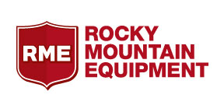
Lead Sponsor:

Platinum Sponsor:

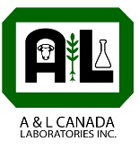
Gold Sponsors:

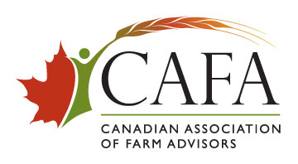
Silver Sponsor:

Bronze Sponsors:
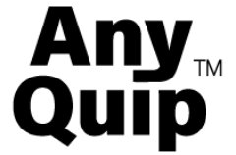

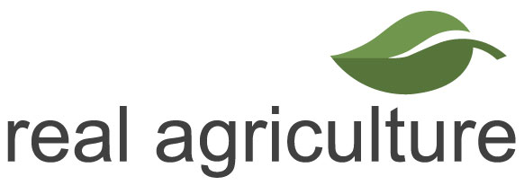
Media Partner:

